DEPARTMENT OF COMPUTER ENGINEERING
CLOUD COMPUTING & FRAMEWORKS
EXPERIMENT NO. 08
CREATING CONTAINERIZED APPLICATIONS WITH DOCKER AND EXPLORING DOCKER HUB
STUDENT DETAILS
Name: Sayyad Faizan
Class/Batch: TE CO - I 03
Roll No.: 24DCO11
Academic Year: 2024-2025
Subject: Cloud Computing & Frameworks (CCF)

1. Aim
To study Docker containerization, create and run a custom containerized web application using a Dockerfile, push the custom image to Docker Hub, and pull/deploy ownCloud server container from Docker Hub.
2. Objectives
• Understand OS-level virtualization, Docker Engine, Dockerfiles, and Docker Hub.
• Master basic Docker CLI commands (`version`, `pull`, `images`, `ps`, `run`, `stop`, `rm`, `rmi`).
• Write a `Dockerfile` using `FROM`, `WORKDIR`, `COPY`, `EXPOSE`, and `CMD` instructions.
• Deploy and verify `owncloud/server` container via browser GUI at `http://localhost:8080`.
3. Theory & Core Concepts
Docker provides OS-level virtualization using Linux namespaces and cgroups. Unlike traditional Virtual Machines, containers share the host kernel while maintaining isolated filesystems and networking.
4. Step-by-Step Lab Execution & Screenshots
Part 1 & 2: Basic Docker Commands & Environment Verification
Verify Docker installation and check local images:
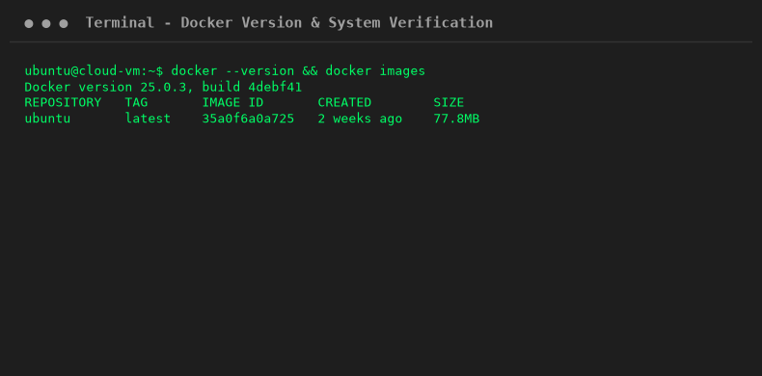
Part 3: Custom Application Dockerfile & Image Build
Write Dockerfile and execute image build command:
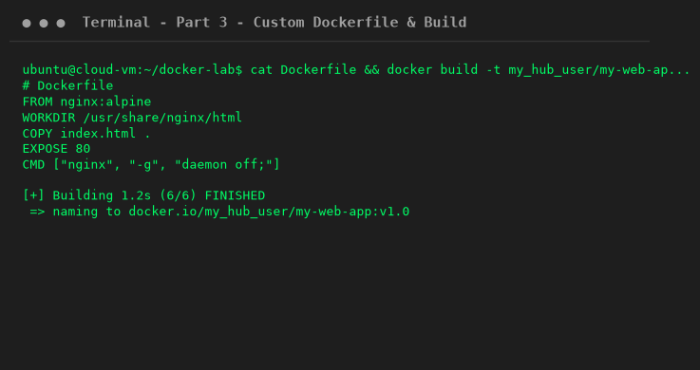
Part 3 (Contd.): Run Custom Container & Push to Docker Hub
Run application container on port 8080 and push image to Docker Hub repository:
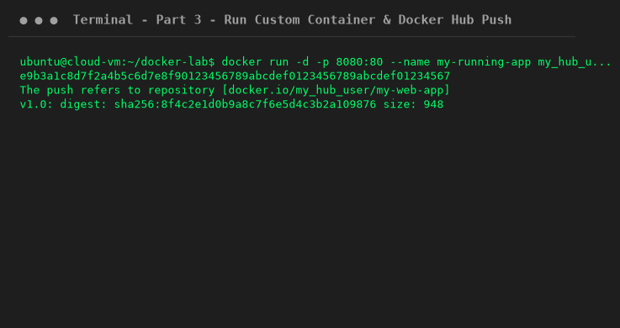
Part 4: Pulling & Running ownCloud from Docker Hub
Pull official `owncloud/server` image and run container instance:
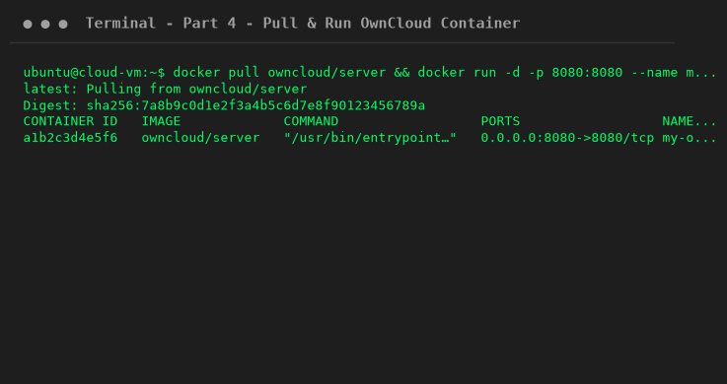
Part 4 (Contd.): Accessing ownCloud Setup Wizard GUI
Access ownCloud server web interface at `http://localhost:8080`:
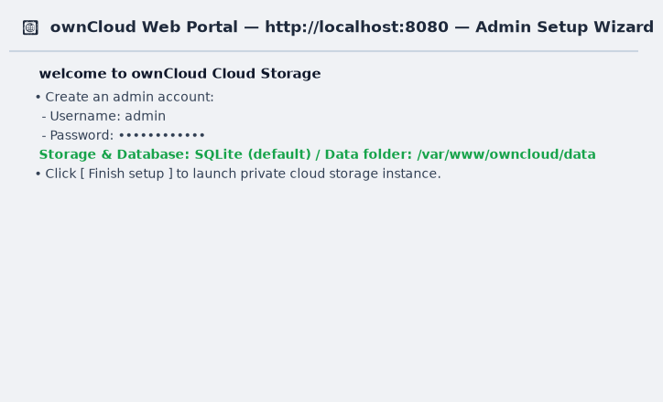
5. Viva Questions & Conclusion
Q1: What is the main advantage of Docker over Virtual Machines?
Ans: Containers share the host kernel and start in seconds with minimal memory overhead.
Q2: What is the purpose of CMD in Dockerfile?
Ans: CMD specifies the default command executed when the container starts.
Q3: What is ownCloud?
Ans: ownCloud is an open-source self-hosted file synchronization and cloud storage platform.
6. Conclusion
In this experiment, Docker containerization steps were executed according to the lab manual. A custom Nginx web app was built and pushed to Docker Hub, and `owncloud/server` was pulled and verified via browser GUI.

